5V DC Power Supply
BYU-Idaho | ECEN – 350 Electronic Devices and Circuits

Shaymon Madrid

Introduction
Our ECEN 350 project is to design and construct a fixed DC Output Power Supply with a current limit that can be either AC or DC powered and has an output voltage between 2.5 V and 9 V. For this project, I chose an output voltage of 5 V. This course provided a range of materials and components to construct the project, including a custom PCB to solder the components to that we select. Components were chosen based on the desired output voltage and from calculating several of the necessary capacitor and resistor values to account for aspects such as ripple voltage, current through the MOSFET and Op-Amp gain. This power supply project implements a voltage regulator using a voltage reference and voltage follower incorporating an n-channel enhancement mode MOSFET transistor and current limit. The schematic for this project can be seen below in Figure 1. The components we needed to calculate values for specifically include Rbias2, R1, Rf, R5, and Cf.

Specifications for this project are listed below:
- AC or DC powered
- 5 V output
- Current limit of approximately 140 mA
- LED power-on indicator

Theory of Operation

Looking at the schematic below (Figure 1), Diodes D1 and D2 are there to direct the current in one direction and rectify an AC input signal. The capacitor Cf was selected for a 60 Hz rectifier input, which produces a ripple frequency of 120 Hz, and it smooths the rectified voltage while reducing ripple. The D3 LED is present on the circuit to be a power-on indicator for the user. The LM385 voltage reference diode is a device that keeps a constant 2.5V for the U1-A non-inverting op-amp. The Zener DZ1 clamps the voltage of that branch when reverse-biased in breakdown, while Rbias1 limits the current through the LED/Zener path. Rbias2 performs a similar function to that of Rbias1 but for the branch with the LM385 voltage reference diode, limiting the current flowing through the branch. These bias resistors also establish the proper operating current for the devices in their respective branches, ensuring correct operation without allowing excessive current that could damage the components.

Resistor R5 serves as a current-sense resistor, and transistor Q1 uses the voltage across R5 to implement current limiting for MOSFET M1. As the drain current of M1 increases, the voltage drop across R5 increases proportionally. When this voltage becomes approximately equal to the base-emitter turn-on voltage of the transistor, Q1 begins to conduct. This conduction pulls down the gate drive of M1, which in turn reduces its conduction and prevents any further increase in current. The value of R5 was selected to set a current limit that would keep the MOSFET’s power dissipation within its allowable thermal limits, protecting the device from damage.

Op-amp U1-B and MOSFET M1 form the main regulating stage of the power supply. U1-A first amplifies the 2.5 V LM385 reference to produce a 5 V reference signal, Vref. U1-B then compares this reference to the actual output voltage and uses the difference as an error signal to control the gate of M1. Since M1 is the series pass device, changing its gate voltage changes how much current flows from the filtered input to the load. If the output voltage drops below 5 V, U1-B raises the MOSFET gate voltage so M1 conducts more strongly and restores the output. If the output voltage rises above 5 V, U1-B lowers the gate voltage so M1 conducts less. This negative-feedback arrangement allows the op-amp and MOSFET to work together to maintain a stable 5 V output.

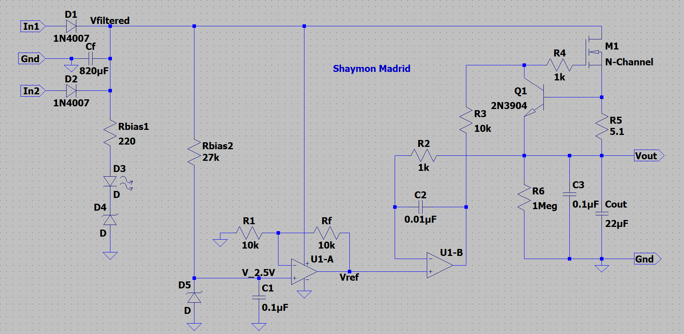
Figure 1: Complete Circuit

Measured Performance

Below are figures and a table to show the performance of the DC power supply. This data was analyzed using a National Instruments Virtual Lab Bench. The plot shown in Figure 2 was made in MATLAB by taking data that was acquired during the measurement portion of the project. 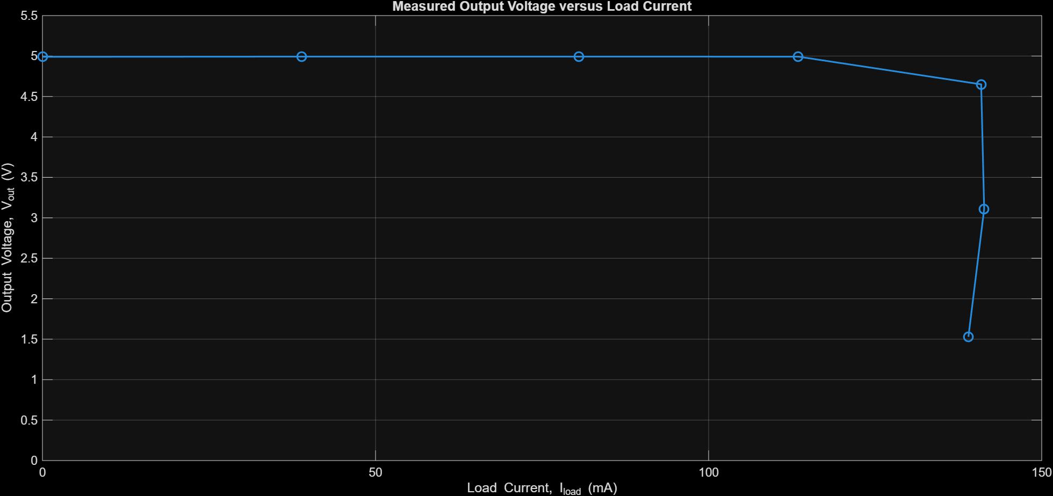
Figure 2: Measured output voltage versus load current for the 5 V DC output power supply.

Figure 2 shows that the output voltage remains close to 5 V over most of the load range, then drops rapidly as the regulator enters current limit near 141 mA. Table 1 below shows different measurements as well as some of the calculations that were made previously.

Table 1: Measured Voltage Regulator Performance Parameters.
Parameter | Measured Values
Minimum DC Input Voltage that turns on the LED Indicator (V). | 13.4 V
Measured Current Limit Value I_{meas} (mA). | 140.91 mA
Percent error between measured and calculated current limit value, with % Error = (100)(I_{meas} – I_{calc} )/(I_{calc}). | 8.18 %
Calculated input voltage ripple for I_{Load} = 0.9I_{calc}. | 1.315 V
Measured input voltage ripple (∆Vfiltered) for I_{Load} ≈ 0.9I_{calc}. (Vpk-pk). | 1.33 V
Measured output voltage for no external load. (V). | 4.99 V
Measured output voltage for I_{Load} = 0.9I_{calc}. (V) | 4.9923 V
120 Hz Ripple Rejection in dB for I_{Load} = 0.9I_{calc}. | 60.4 dB

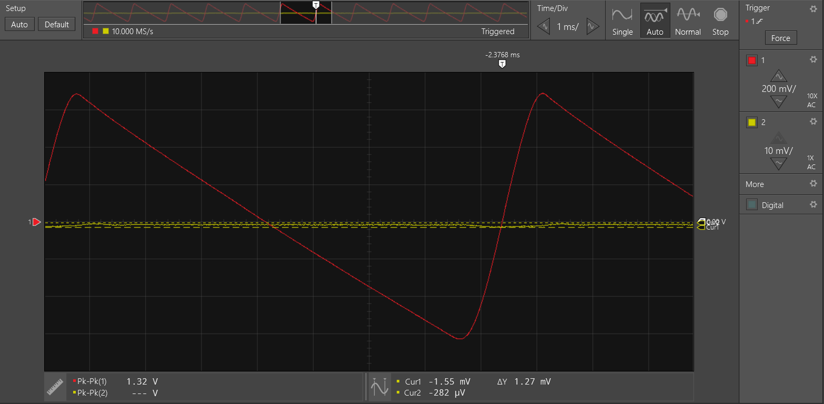
Figure 3: Oscilloscope measurement of output voltage ripple at approximately 0.9Icalc, with input ripple also displayed for ripple rejection calculation

Discussion and Conclusions

Overall, the power supply successfully produced a regulated 5 V output and entered current limit near the expected value. The measured output voltage remained close to 5 V over most of the load range and then dropped as the regulator entered current limit near 141 mA. The measured ripple rejection also showed that the regulator significantly reduced the input ripple at the output. This project helped reinforce the operation of rectification, voltage regulation, MOSFET pass devices, and feedback control. A future improvement would be to refine the current-limit behavior and improve the presentation of measured ripple data.
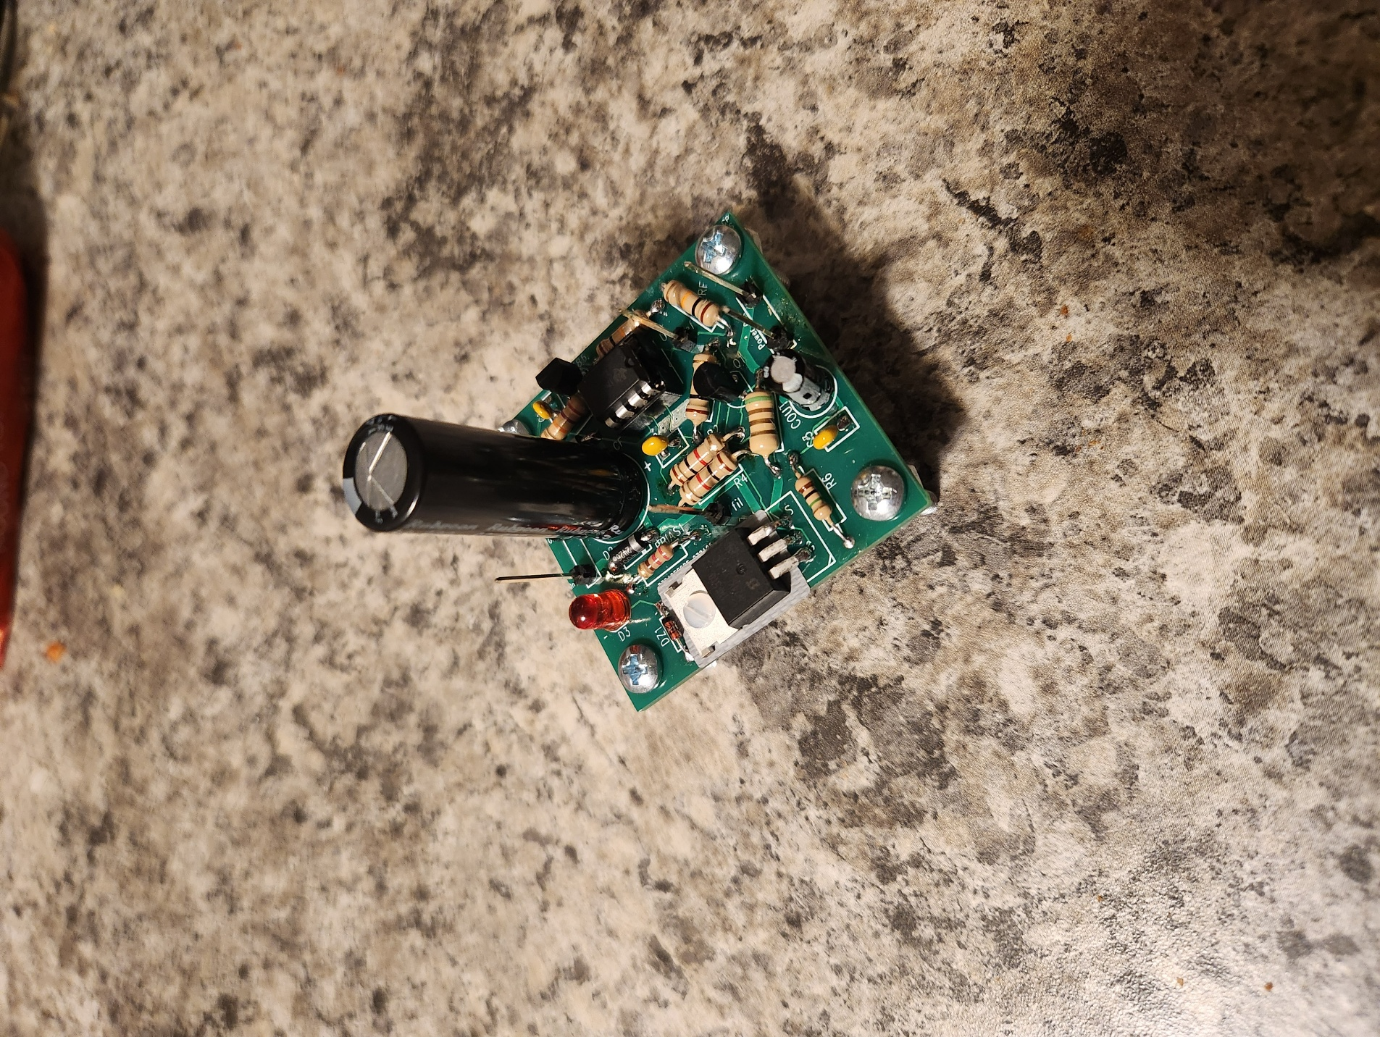
Figure 4: Completed DC Power Supply

